Osirian Ninjutsu

Ninjutsu Mastery

Ninjutsu Mastery
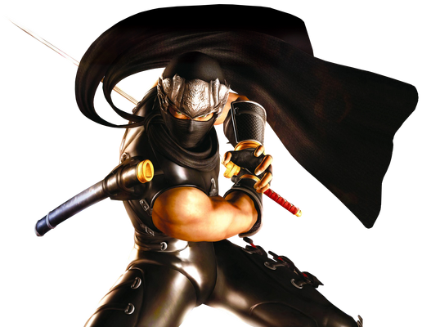

"The Singular Super Ninja" Ryu Hayabusa (Ninja Gaiden) is the most skilled ninja in the world.

Power/Ability to:
Be a master of historical and/or fictional ninjutsu.
"A samurai would never sneak or cheat. A samurai would never assassinate. A samurai would never sabotage. But a ninja would sneak up and stab you in the back!"
― Stick (Marvel Comics)
"I hate it when he does that!"
― Miyamoto Usagi to Tomoe Ame on Leonardo (Teenage Mutant Ninja Turtles)
"Ninjutsu was originally designed for guerrilla warfare, emphasizing deception, trickery, ambush, sabotage and most of all pragmatism. Despite its various changes through time, its emphasis on pragmatism alone has never changed."
― Issei Hyodou (Highschool DxD)
The ability to be a master of Ninjutsu, the historic style of martial arts, tactics, strategy, and espionage of unconventional and guerrilla warfare, either innately or through training. Variation of Intuitive Aptitude, Complete Mastery, and Martial Arts Mastery. Those who practice this style are known as Ninja, male ninja being shinobi and female ninja being kunoichi.

Also Called
- Kunoichi Arts/Intuition/Mastery/Training
- Ninja Arts/Intuition/Mastery/Training
- Ninjutsu
- Shinobi Arts/Intuition/Mastery/Training

Capabilities
User possesses an innate understanding of Ninjutsu, the historic style of martial arts, tactics, strategy, and espionage of unconventional and guerrilla warfare. Contrary to popular culture, real-life ninja were mainly spies, saboteurs, and assassins that rarely appeared on the battlefield. Depending on the school and source ninjutsu focuses on different disciplines.
The most common of which was the twenty disciplines of the Bujinkan:
- Seishinteki kyōyō (spiritual refinement)
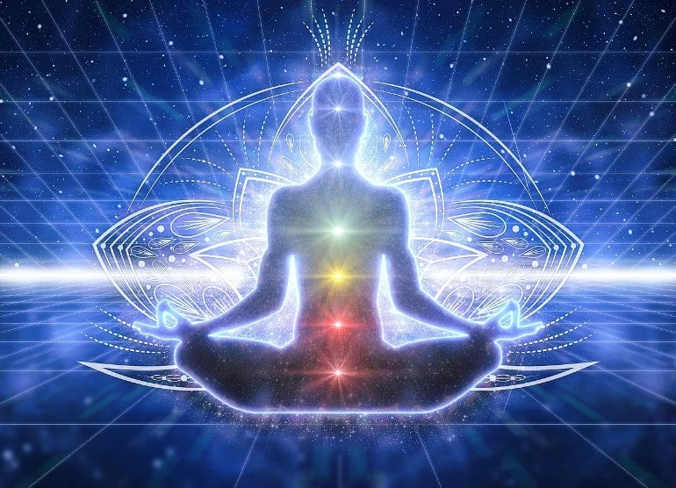
Seishin-teki kyôyô
Points for spiritual refinement:
Knowing one's self
Knowing nature
Destiny (can be translated as calling)
Harmony
The Heart
The Eye
Love
"Nobody can use the bathroom for you; you must relieve your suffering in your own way. If you are done relieving your suffering, then your mind will be a polished mind, like a mirror, it will reflect clearly on the moment, undistracted by your needs."
Meditation is a great way to develop a polished mind. It makes you calm and relaxed, And you will be able to control your adrenaline by making sure, You are always calm, Therefore always low, And you wont have to worry about freezing up. Ok, Now let's move on to some meditation methods.
Find a quite place, Dry and comfortable, Then sit down. When you breath in through your nose, Your stomach pushes out, Breath in through your nose, and your stomach sucks in. Relax, And stay calm, Try just to be a rock, Feel as if you are a rock, No obligations. Feel all your obligations, Need's and worries fly out the door. Now focus on only onr thought, Like a car, then focus on one part of the car the tire. Only think about the tire. And keep focusing on it, Until all the other thoughts leave. Now focus on your breathing In through the nose, Out through the nose, Have a whole thought pattern on this. This is a great method, And I suggest daily meditation.
Now I want you to get Some paper and a pen. Write down everything bad you have ever done on a few sheets of paper, And all the bad qualities about yourself. Do this for one week or adleast until you think its done. Then write down all the good qualities about yourself and good things you have done. Be honest with yourself if you want this to actually work. And then when your done. Look over the bad qualities and make solutions on fixing them, And actually implement them. And then try to make your good qualities shine more.
This part is for knowing your destiny, Or your calling. What I want you to do is, Picture what you want to be, or your dream job, Or Exactly how you want your life to be like, And what you want. Now write down What you want to be, And have. Be honest here. Then on the piece of paper you wrote it on, Make a solution on how to follow through with that plan.

- Taijutsu (unarmed combat)
Taijutsu (体術, literally "body technique" or "body skill") is a Japanese martial art blanket term for any combat skill, technique or system of martial art using body movements that are described as an empty-hand combat skill or system. Taijutsu is a synonym for Jujutsu (method of unarmed or with minor weapons close combat). The words jujutsu, taijutsu, and yawara can be used interchangeably. The term is commonly used when referring to a traditional Japanese martial art but has also been used in the naming of modern martial arts such as Gendai Goshin Jutsu, Yamabujin Goshin-Jutsu and Bujinkan Budo Taijutsu. Taijutsu is similar to Karate but is more focused on the body techniques. More specific names than taijutsu are typically used when describing a martial art: Judo (focusing on throwing and grappling), Aikido (focusing on throwing and joint locks) as well as Karate and Kenpō (focusing on striking).

- Kenjutsu (sword techniques)
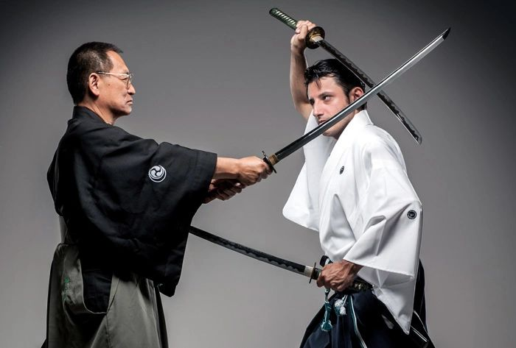
Kenjutsu (剣術) is an umbrella term for all (ko-budō) schools of Japanese swordsmanship, in particular those that predate the Meiji Restoration. Some modern styles of kendo and iaido that were established in the 20th century also included modern forms of kenjutsu in their curriculum.^{[1]} Kenjutsu, which originated with the samurai class of feudal Japan,^{[2]} means "methods, techniques, and the art of the Japanese sword". This is opposed to kendo, which means "the way of the sword" and uses a bamboo sword (shinai) and protective armour (bōgu).^{[3]}
The exact activities and conventions undertaken when practicing kenjutsu vary from school to school, where the word school here refers to the practice, methods, ethics, and metaphysics of a given tradition, yet commonly include practice of battlefield techniques without an opponent and techniques whereby two practitioners perform kata (featuring full contact strikes to the body in some styles and no body contact strikes permitted in others).^{[4]} Although kata training has always been the mainstay, in later periods, schools incorporated sparring under a variety of conditions, from using solid wooden bokutō to the use of a bamboo sword (shinai) and armor (bōgu).^{[3]: XII, XIII} In modern times sparring in Japanese martial art is more strongly associated with kendo and is mainly practiced by students or the police force. Although kendo is common in Japan, it is also practiced in other countries around the world.

- Bōjutsu (stick and staff techniques)
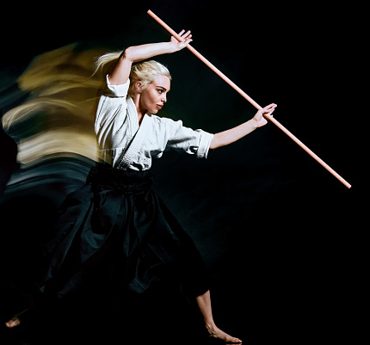
Bōjutsu (棒術), translated from Japanese as "staff technique", is the martial art of stick fighting using a bō, which is the Japanese word for staff.^{[1][2]} Staffs have been in use for thousands of years in Asian martial arts like Silambam. Some techniques involve slashing, swinging, and stabbing with the staff. Others involve using the staff as a vaulting pole or as a prop for hand-to-hand strikes.
Today bōjutsu is usually associated either with Okinawan kobudō or with Japanese koryū budō. Japanese bōjutsu is one of the core elements of classical martial training.
Thrusting, swinging, and striking techniques often resemble empty-hand movements, following the philosophy that the bō is merely an "extension of one’s limbs".^{[3]} Consequently, bōjutsu is often incorporated into other styles of empty-hand fighting, like traditional Jū-jutsu, and karate.
In the Okinawan context, the weapon is frequently referred to as the kon (棍).

- Sōjutsu (spear techniques)
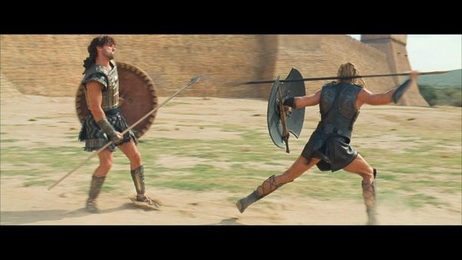
Sōjutsu (槍術), meaning "art of the spear", is the Japanese martial art of fighting with a Japanese spear (槍, yari).

Although the spear had a profound role in early Japanese mythology, where the islands of Japan themselves were said to be created by salt water dripping from the tip of the spear Ame-no-Nuhoko (Heavenly jeweled spear), as a weapon the first spear prototypes were brought from mainland Asia. These early versions were not seen as suitable by the Japanese, who later redesigned them once technology permitted.^{[1]}

The Yari was a popular weapon throughout the feudal period of Japan,^{[2]} being cheaper to produce and requiring less training than other contemporary battlefield weapons, and lending itself to close formations of ashigaru troops, in conjunction with firearms upon their adoption in Japan. The height of sōjutsu's popularity was immediately after the Mongol invasions of the 13th century, who themselves used spearmen in great numbers.^{[1]}
The Japanese ultimately modified the heads of their spears into a number of different variations, leading to the use of the spear both on foot and from horseback, and for slashing as well as the primary use of attacking with thrusts.^{[1]}

Sōjutsu is typically only a single component of curriculum in comprehensive traditional (koryū) schools. The still extant Tenshin Shōden Katori Shintō-ryū claims to be the first school to include sōjutsu in its formal curriculum, and another very well known school of sōjutsu is the Hōzōin-ryū. While today there are very few schools still teaching sōjutsu, at one time there were as many as 450.^{[1]}

- Naginatajutsu (naginata techniques)
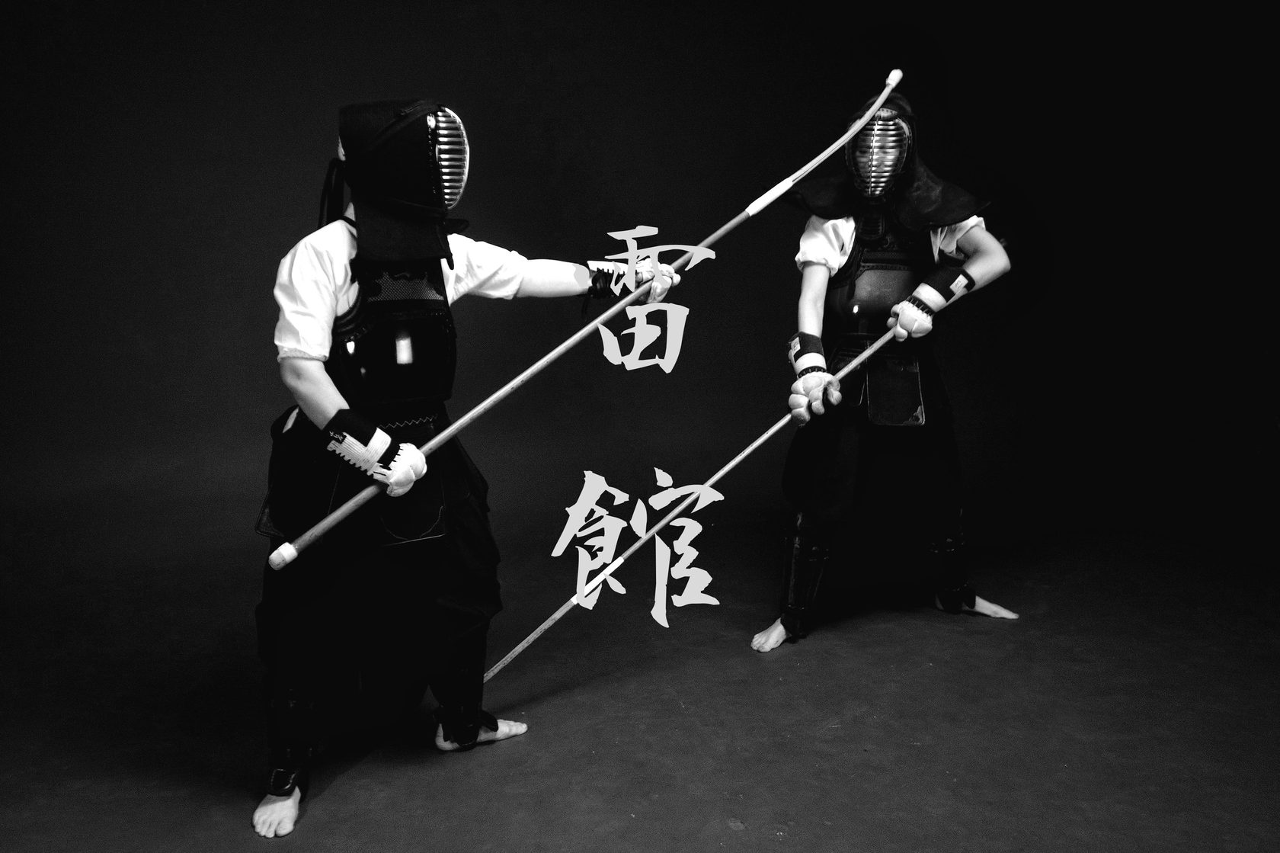
Naginatajutsu (長刀術 or 薙刀術) is the Japanese martial art of wielding the naginata (長刀). The naginata is a weapon resembling the medieval European glaive and the Chinese guan dao. Most naginatajutsu practiced today is in a modernized form, a gendai budō, in which competitions also are held.

The naginata originates from development of the Japanese spear called hoko yari of the later 1st millennium AD.^{[1][2]} It has been suggested that it developed along the same lines as Okinawan kobudō weapons as a modified farming tool. Others say that creative samurai in need of a longer weapon attached a sword to a pole. Perhaps the simplest explanation is the natural development of polearms. Polearms are intended as mass weapons, to be used not just by individual warriors, but by formations of soldiers together on field battles and not for dueling. When fighting in close order, two-handed cut-and-thrust weapons, such as halberds and glaives, are much more efficient than mere spears or swords because of their versatility compared to spears and longer reach compared to swords. Fighting in massed formation does not require similar individual weapon-handling skills as required by a skilled swordsman. Naginata are almost identical in appearance to both the glaive and the guan dao, and it is most likely result of parallel evolution.

- Kusarigamajutsu (kusarigama techniques)
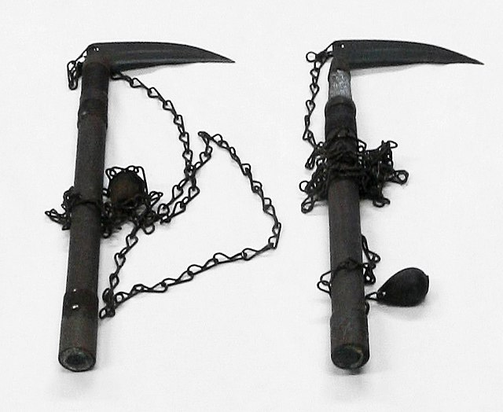
Kusarigamajutsu (鎖鎌術:くさりがまじゅつ) is the art of using the Japanese weapon kusarigama.
Kusarigamajutsu is featured in several separate martial arts such as Tendō-ryū, Suiō-ryū and Shintō Musō-ryū. The kusarigama is made up of three parts: the kama (a wooden handle with a curved blade (traditionally straight) protruding at a right-angle on one end, and a small loop at the other), and the kusari (a chain attached to the kama) and a weight at the end of the chain. In a confrontation the kusari is swung in wide sweeping arcs to distract and entangle the opponent and the kama is used to deliver a fatal strike.

- Shurikenjutsu (throwing weapons techniques)
- Kayakujutsu (pyrotechnics)
- Hensōjutsu (disguise and impersonation)
- Shinobi-iri (stealth and entering methods)
- Bajutsu (horsemanship)
- Sui-ren (water training)
- Bōryaku (tactics)
- Chōhō (espionage)
- Intonjutsu (escaping and concealment)
- Tenmon (meteorology)
- Chi-mon (geography)
- Kuji-Kiri (Esoteric Hand-Seal Practice)
- Hojojutsu (Rope techniques)
Various types of weaponry are also associated with a ninja.
- Kusarigama
- Kyoketsu shoge
- Kusari-fundo
- Kakute
- Shobo
- Shuriken
- Tekko
- Kunai
- Shikoro
- Fukiya
- Makibishi
- Shuriken
- Yumi and Ya
- Tekagi-shuko
- Tekko-kagi
- Bō
- Nunchaku
- Sai
- Tessen
- Tonfa
- Yari
- Nagamaki
- Naginata
- Katana
- Wakizashi
- Ninjato
- Tachi
- Tantō
- Bokken
- Shinai
- Kaginawa or grappling hook
- Rope

Applications
- Adoptive Muscle Memory
- Athletic Combat
- Aura Manipulation
- Chameleonic Nature
- Chi Manipulation
- Climbing
- Disguise Mastery
- Enhanced Agility
- Enhanced Combat
- Enhanced Speed
- Escape Artistry
- Intuitive Aptitude
  - Assassination Mastery
  - Deception Mastery
  - Infiltration Mastery
  - Martial Arts Mastery
    - Mixed Martial Arts Intuition
      - Athletic Combat
      - Aikido Mastery
      - Ansatsuken Mastery
      - Boxing Mastery
      - Capoeira Mastery
      - CQC Mastery
        - MCMAP Mastery
      - Eskrima Mastery
        - Stick-Fighting Mastery
      - Fencing Mastery
      - Gōjū-ryū Intuition
      - Gun Kata
      - Iaijutsu Mastery
      - Judo Mastery
      - Karate Mastery
      - Kendo Mastery
      - Kickboxing Mastery
      - Kyudo Mastery
      - Kung Fu Mastery
        - Jeet Kune Do Mastery
        - Tai Chi Mastery
      - Lucha Libre Mastery
      - Mystical Martial Arts
      - Muay Thai Mastery
      - Ninpo Arts
        - Ninja Magic
      - Pankration Mastery
      - Pressure Point Combat
      - Sambo Mastery
      - Wrestling Mastery
        - Lucha Libre Mastery
        - Sambo Mastery
        - Sumo Wrestling Mastery
    - Unarmed Combat Mastery
      - Ambush Mastery
      - Blocking Mastery
      - Countering Mastery
      - Evading Mastery
  - Medical Mastery
    - Healing
    - Herbalism
  - Military Mastery
  - Poisoning Mastery
    - Poison Artillery
    - Poison Weaponry
  - Psychological Intuition
    - Body Language Analysis
      - Combat Perception
  - Rope Intuition
  - Special Ops Mastery
  - Stealth Intuition
  - Surveillance Intuition
  - Trapping Intuition
  - Weapon Proficiency/Improbable Weapon Proficiency
    - Dual Wielding
    - Enhanced Archery
    - Enhanced Flailmanship
      - Chain Proficiency
      - Sickle Proficiency
      - Hook Proficiency
      - Kusarigama Proficiency
      - Lasso Proficiency
      - Grappling Proficiency
    - Enhanced Nunchakumanship
    - Enhanced Saimanship
    - Staff Proficiency
      - Polearm Proficiency
        - Halberd Proficiency
          - Naginata Proficiency
      - Staff Proficiency
      - Spear Proficiency
      - Scythe Proficiency
      - Lance Proficiency
      - Podao Proficiency
    - Enhanced Swordsmanship
      - Katana Proficiency
      - Knife Proficiency
      - Machete Proficiency
      - Switchblade Proficiency
      - Jian Proficiency
      - Sabre Proficiency
    - Enhanced Whipmanship
      - Whip Proficiency
      - Whip Sword Proficiency
    - Melee Weapon Proficiency
      - Double-Sided Weapon Proficiency
        - Dual-Headed Blade Proficiency
      - Flexible Weapon Proficiency
    - Broken Weapon Proficiency
    - Ranged Weapon Proficiency
      - Throwing Weapon Proficiency
      - Bola Proficiency
      - Boomerang Proficiency
      - Explosive Proficiency
        - Smoke Bomb Proficiency
      - Needle Proficiency
      - Flying Disc Proficiency
      - Shuriken Proficiency
      - Kunai Proficiency
    - Axe Proficiency
    - Slingshot Proficiency
  - Qigong Mastery
- State of Mind
- Wallrunning

Associations
- Alien Physiology
  - Alien Combat
- Assassin
- Bionic Physiology
  - Artificial Physiology
  - Android Physiology
  - Technorganic Physiology
    - Artificial Martial Arts
- Gesture Casting
- Mortal Physiology
- Mystic Human Physiology
  - Mystical Martial Arts
- Ninja
- Spy
- Super Soldier
- Superior Human Physiology
  - Meta-Human Combat
- Training Regimen

Limitations
- May need a certain degree of exposure (training, observation, etc.) to be an effective ninja.

